2020 Salem KAPPA CHI Flower Sale - Orders due by March 31st
Pick up Date will be Friday May 8th from 5:30-6:45 p.m. at First English Lutheran Church: 725 East Forrest Hill, 61603; Salem orders can be delivered upon request.

Customer ________________________ Phone Number ___________________

Standard Annuals
Full Flats contain 48 plants |  |  |  |  | ½ Flats contain 24 plants
 | ½ Flat | Full Flat |  |  | ½ Flat | Full Flat |  |  | ½ Flat | Full Flat
 | $10.00) | $19.00) |  |  | $10.00) | $19.00) |  |  | $10.00) | $19.00)
Ageratum |  |  |  | Impatiens |  |  |  | Petunia
Tycoon Blue |  |  |  | Dazzler Deep Pink |  |  |  | Bravo Blue
 |  |  |  | Dazzler Red |  |  |  | Bravo Red
Begonia |  |  |  | Dazzler Voo Doo Mix |  |  |  | Bravo White
Ambassador Scarlet |  |  |  |  |  |  |  | Bravo Formula Mix
Ambassador White  Ambassador Mix |  |  |  | Marigold - Reg
 |  |  |  | Hero Yellow |  |  |  | Portulaca
 |  |  |  | Hero Mix |  |  |  | Sundial Mix
Coleus |  |  |  | Disco Red |  |  |  | Salvia
Fairway Mix |  |  |  | Pansy |  |  |  | Flare Red
 |  |  |  | Delta Mix |  |  |  | Victoria Blue
Dahlia Mix
Figaro Mix |  |  |  | Petunia - Double |  |  |  | Snapdragons
 |  |  |  | Dbl. Cascade Mix |  |  |  | Snapshot Mix
Dianthus |  |  |  |  |  |  |  | Rocket Mix, Tall
Floral Lace True Rose |  |  |  |  |  |  |  | Verbena
Floral Lace Crimson |  |  |  |  |  |  |  | Obsession mix
Floral Lace White
 |  |  |  |  |  |  |  | Vinca
Dusty Miller |  |  |  |  |  |  |  | SunStorm Mix
Silverdust
Side 1
Side 1 Cost Calculation
Type of Plant
#
Cost
Total
Total number of Standard
Annual Full Flats
x $19.00
Total number of Standard
Annual 1/2 Flats
x $10.00
Total Cost for Side 1:
Please complete the table below for the total of side 1.
**Cannot guarantee colors - Substitutions may be made**

Please turn over for side 2 →
Salem Flower Sale – Orders due by March 31st
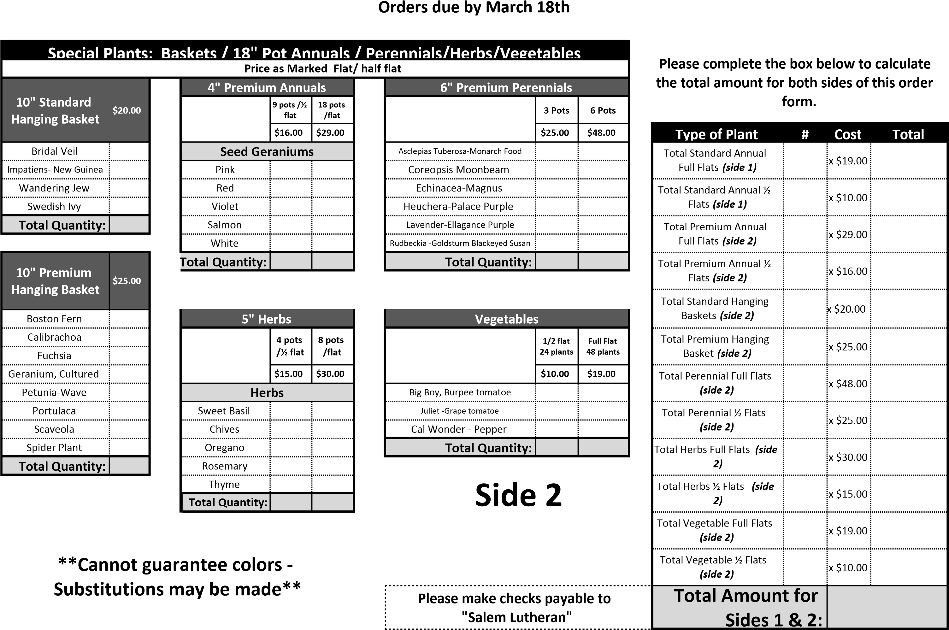

Pick up Date will be Friday May 8th from 5:30-6:45 p.m. at First English Lutheran Church: 725 East Forrest Hill, 61603; Salem orders can be delivered upon request.
PLEASE RETURN THIS FORM (OR YOUR WRITTEN ORDER) TO JGOLDHAMMER@SALEMOFPEORIA.COM BY NOON ON MARCH 31, 2020. Payment due before pick up.

